Report on learning practice # 4

Stationarity of the processes

Performed by:

Performed by:

Grandilevskii Aleksei

J4133c

Dubinin Ivan

Sorokin Mikhail

J4132c

Saint-Petersburg

2021

**Table of contents:**

1. Substantiation of chosen sampling.

This Lab we used to have timestamps in our dataset. Dataset we used in the previous works hasn’t them. But the specialized dataset from labs 1-3 is a processed squeeze from the raw data obtained using the Riot.API. (<https://www.kaggle.com/gyejr95/league-of-legendslol-ranked-games-2020-ver1#challenger_match_V2.csv>). The original dataset contains 7Gb of practically raw data from the API. We wrote our own script for parsing timestamps from raw data and already processed dataset.

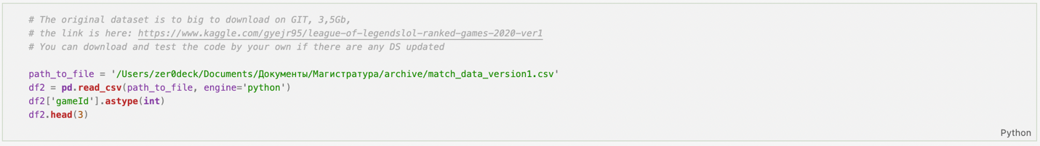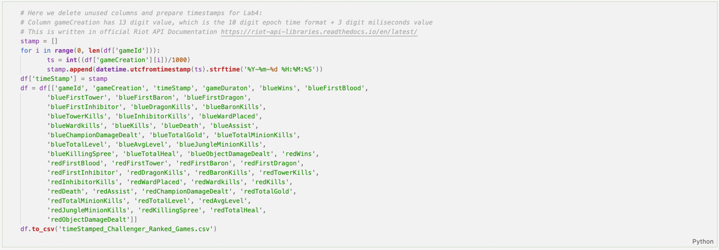

*Pic.1. Timestamps parsing.*

As You can see in the code timestamps are timestamps are represented as Unix-ts, so our script also converts them into default Python 3 timestamps.

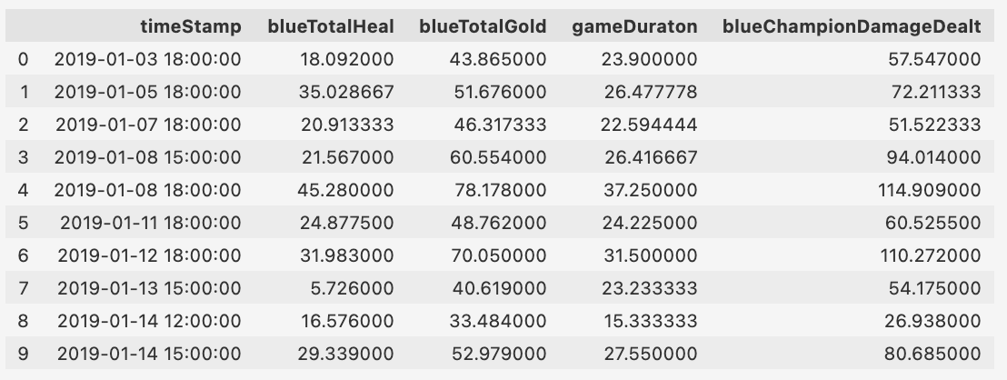

*Pic.2. Working dataset for lab 4 visualization.*

For this task were chosen these target variables: *blueTotalHeal, blueTotalGold* and following predictors: *gameDuraton, blueChampionDamageDealt. timeStamp* variable contains timestamps for our data. Time series for all chosen variables aggregated by 3 hours with mean value are shown on the picture below.

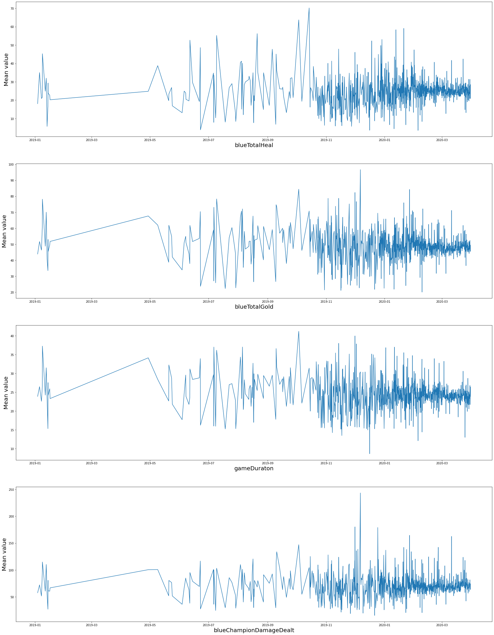

Pic.2 – Initial time series for all variables

2. Stationary analysis.

As one can easily see gained time series represent non-stationary processes. To make them more stationary space part till 2020-01-01 was removed. The gained time series are presented on picture 3. All this time series passed Augmented Dickey-Fuller Test and can be considered stationary. The Results of Dickey-Fuller Test are presented for each variable on the table below.

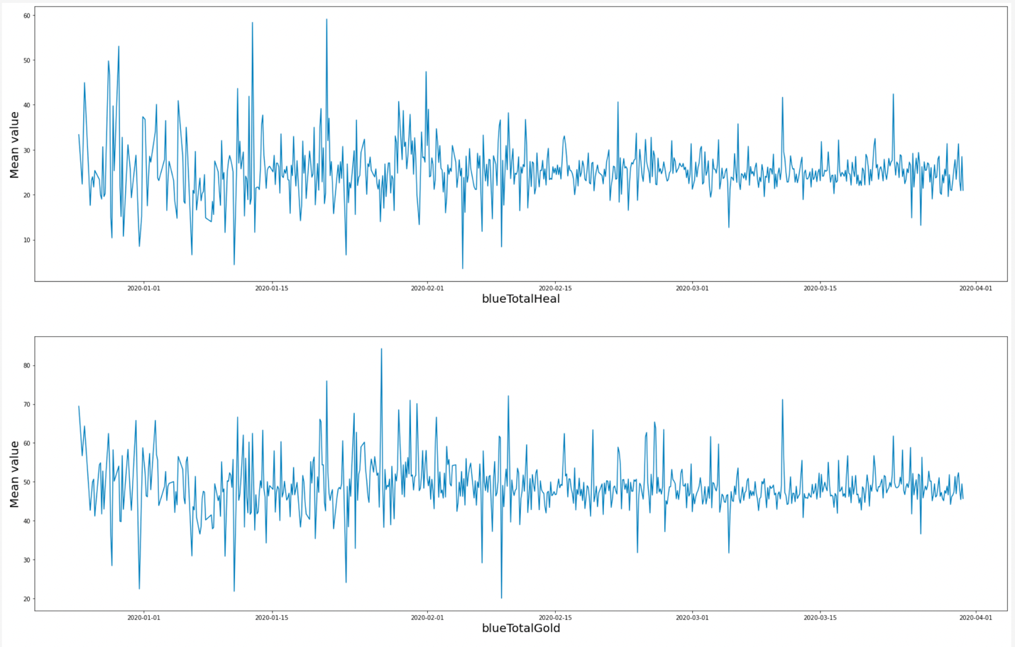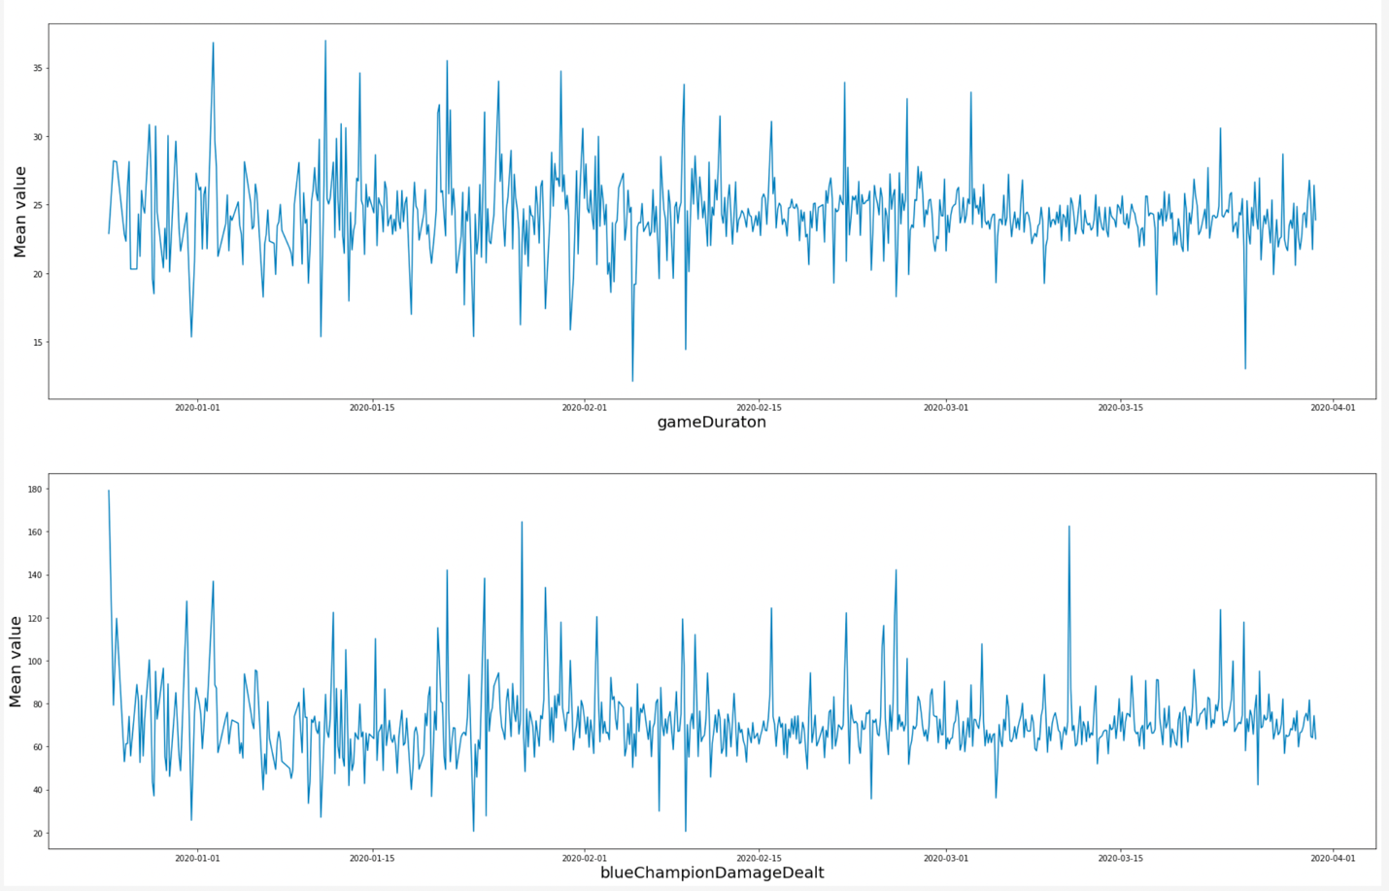

*Pic.3. Gained stationary process.*

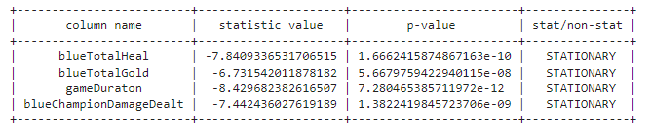

*Pic.4. ACF*

3. Covariance or correlation function analysis.

Picture 4 represents Auto-covariance function for target variables. On picture 5 Auto-covariance function gained using window of 30 items is shown. These functions look like their processes are stationary.

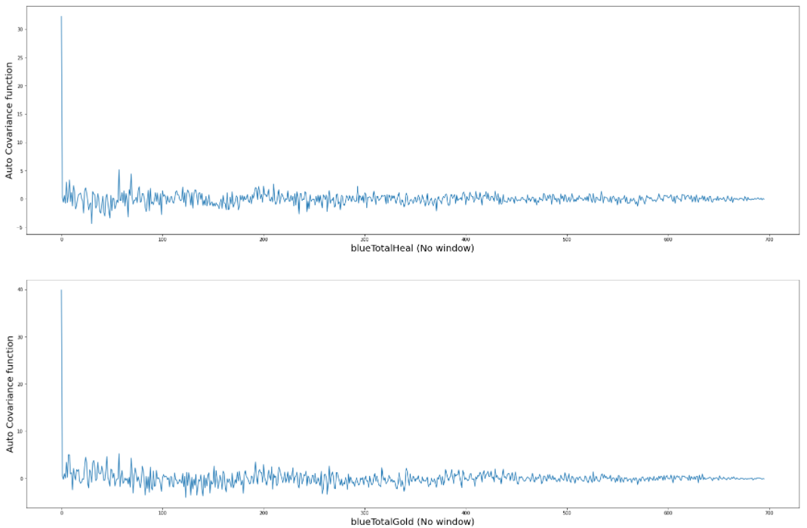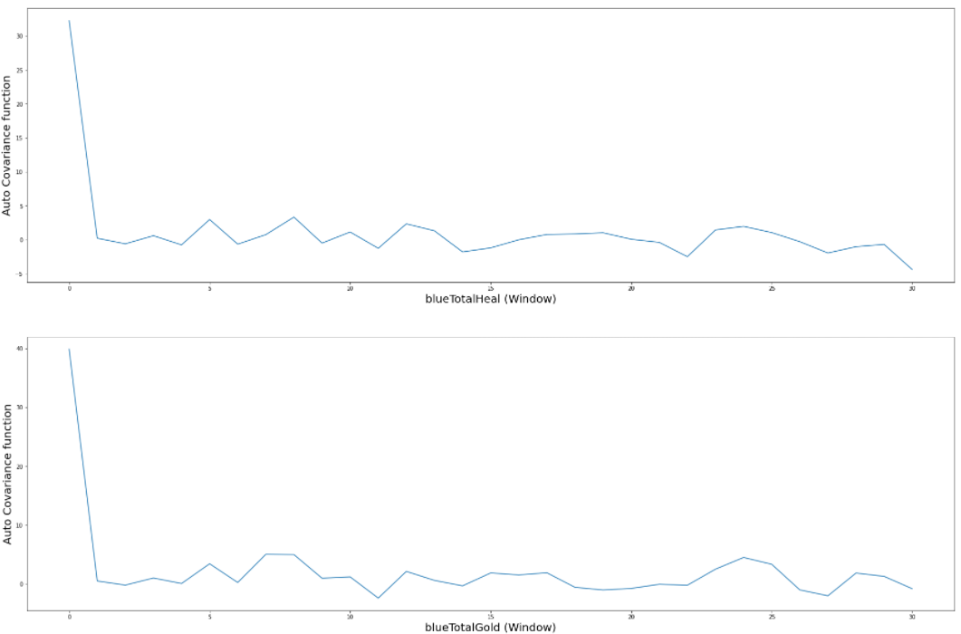

Picture 6 represents cross-covariance (mutual correlation) function between each target and predictor variable

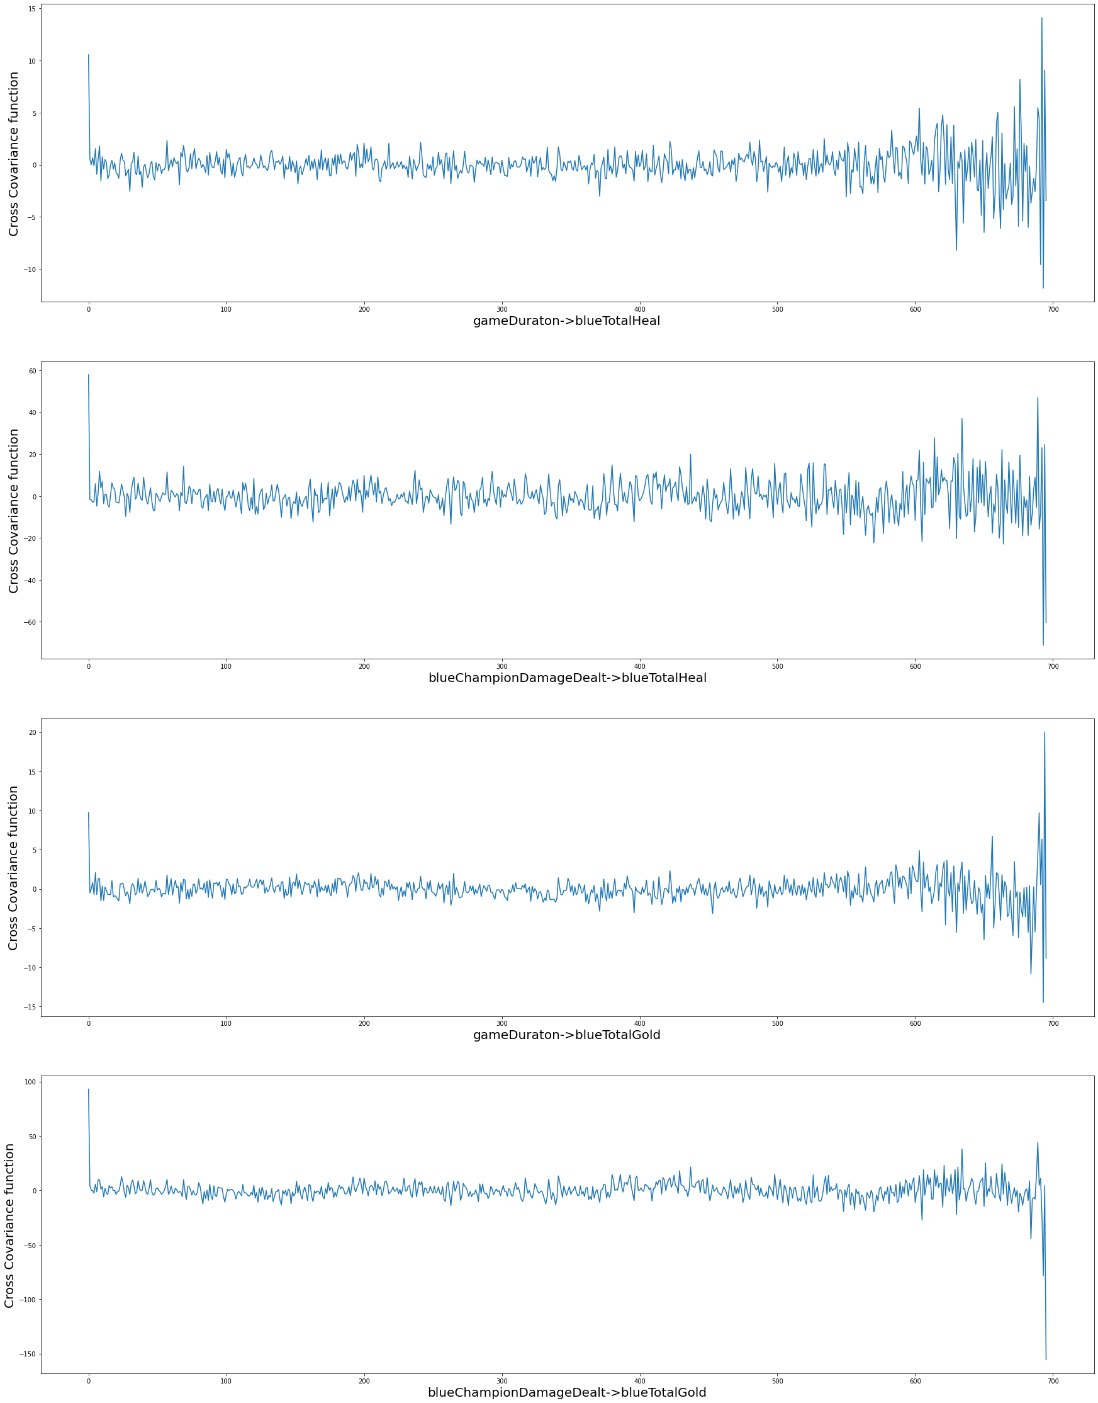

*Pic.6. Cross-covariance functions.*

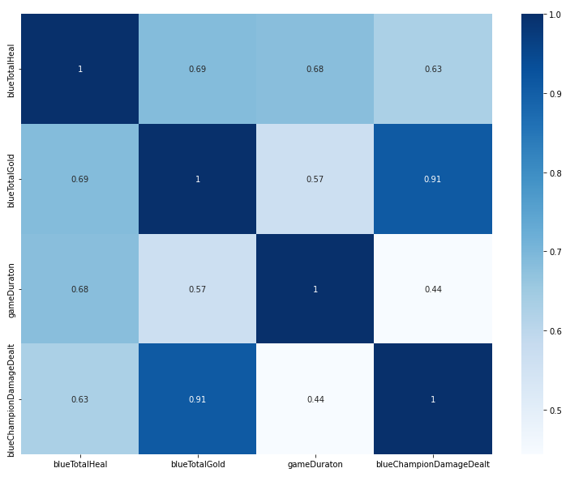Cross correlation matrix for variables is presented on picture 7. As one can see, target and predictor variables are highly correlated, especially BlueTotalGold is correlated with blueChampionDamageDealt.

*Pic.7. Cross correlation matrix.*

4. Noise filtration.

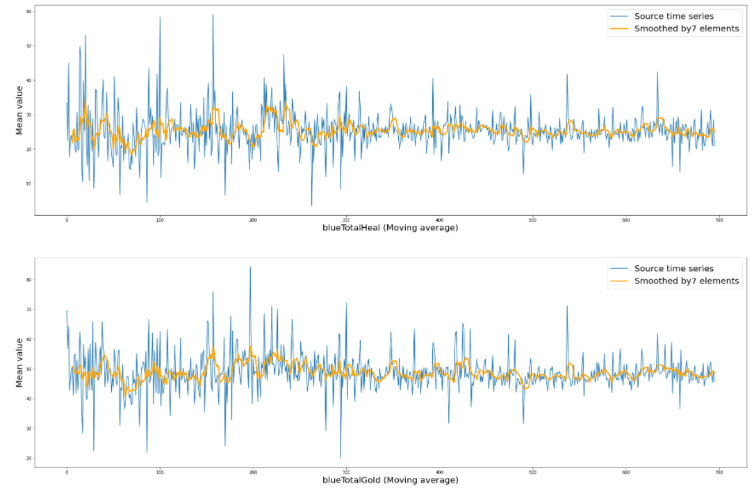For filtering high frequencies Moving average filter (Pic.8) and Gaussian filter (Pic.9) from FEDOT framework were used.

*Pic.8. Using Moving average filter.*

*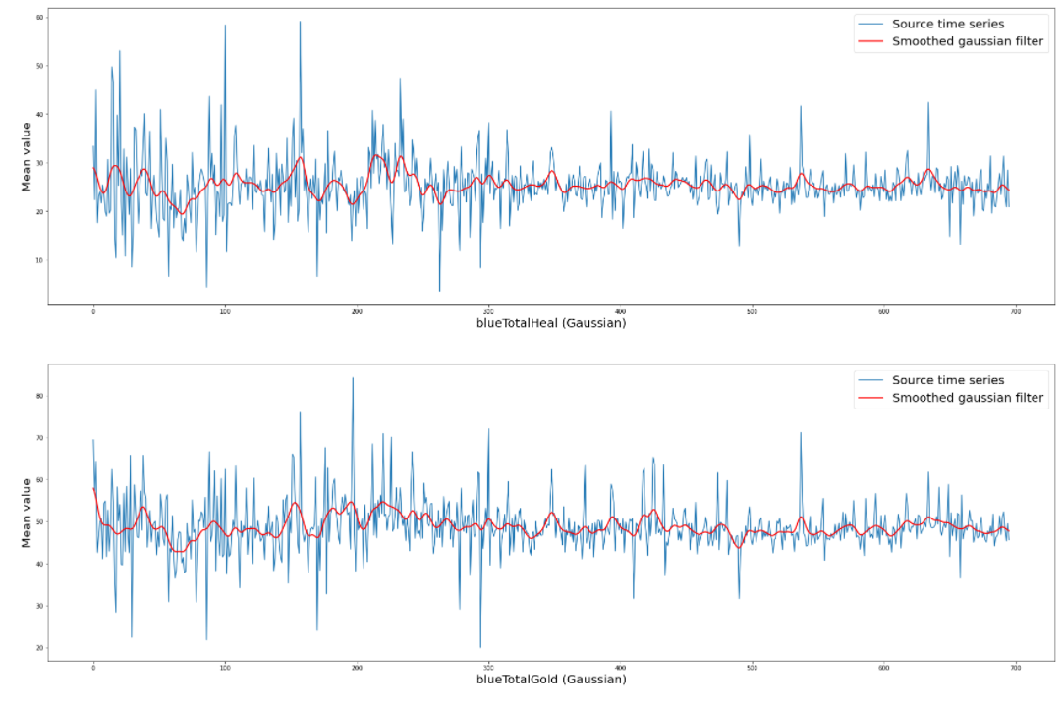Pic.9. Using Gaussian filter.*

5. Estimation of spectral density function.

Spectral density using was estimated Welch’s method from scipy.signal module. The results for both non-filtered and filtered time series are presented on picture 10. There are two plots for each target variable. Two different filters are shown using different colors: orange for Moving average and red for Gaussian filter.

As one can see both filters removed high frequencies from spectral density function.

*Pic.10. Spectral density functions.*

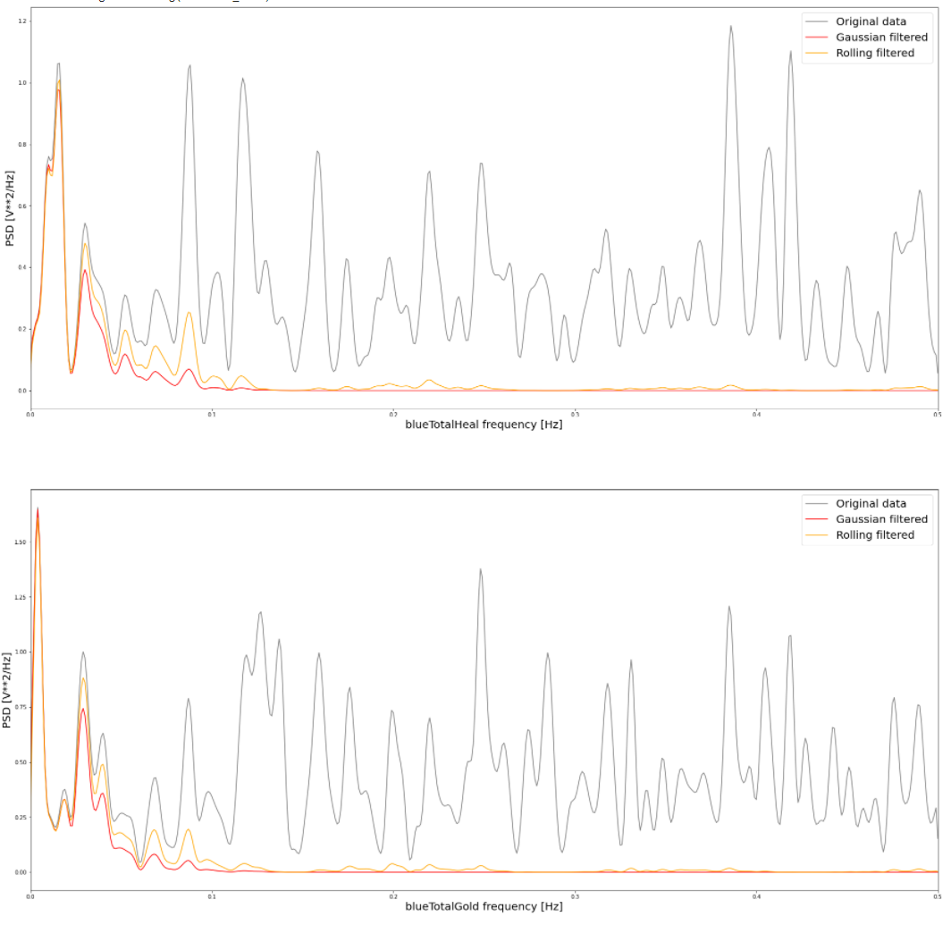

6. Auto-regression model.

For building Auto-regression model AR Pipeline from FEDOT framework was used. The generated auto-regression model was used to forecast the future values of time series. All in all there were built four AR models – for both filtered and non-filtered time series of both target variables. The result of forecasting for non-filtered time series are shown on picture 11, for filtered data – on picture 12.

As one can see the generated forecasts are not accurate.

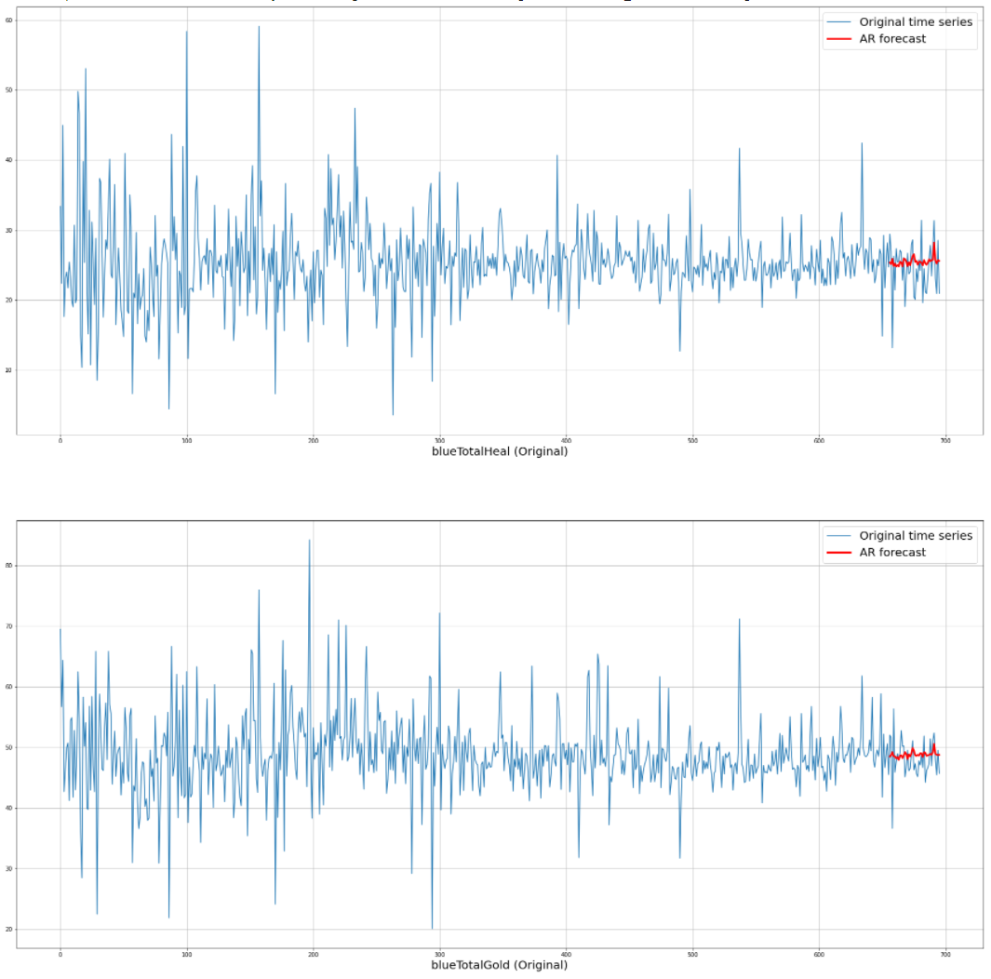

*Pic.11. AR model forecasting non-filtered time series.*

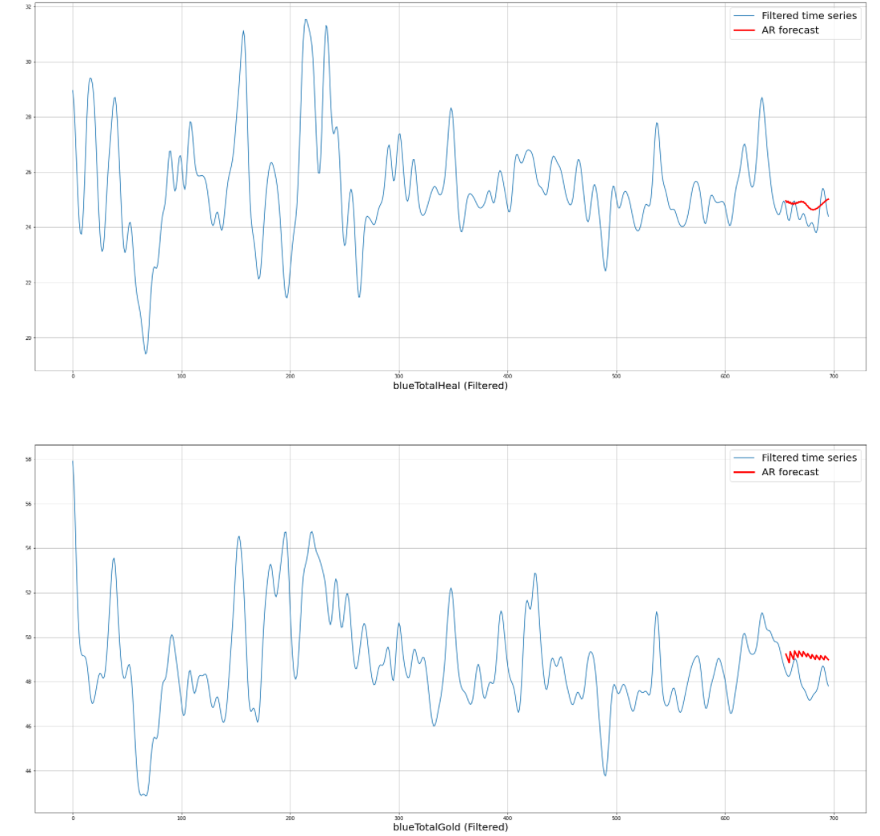

*Pic.12. AR model forecasting filtered time series.*

For building Seasonal AutoRegressive Integrated Moving Average with eXogenous regressors model (SARIMA) function SARIMAX from *statsmodels* module was used. The parameters for these models can be seen in [Jupyter notebook](https://github.com/vandosik/M-M-MSA/blob/master/Lab_4/lab_4.ipynb) for this laboratory work The generated SARIMA model was used to forecast the future values of time series. All in all there were built four SARIMA models – for both filtered and non-filtered time series of both target variables. The result of forecasting for non-filtered time series are shown on picture 13, for filtered data – on picture 14.

As one can see the generated forecasts are rather better comparing with AR model results.



*Pic.13. SARIMA model forecasting non-filtered time series.*



*Pic.14. SARIMA model forecasting filtered time series.*

**Sourcecode:**

* The full repository with all the labs: <https://github.com/vandosik/M-M-MSA>
* The repo with Datasets and additional used Data info: <https://github.com/vandosik/M-M-MSA/tree/master/Datasets>
* The Lab 4 ipynb file: <https://github.com/vandosik/M-M-MSA/blob/master/Lab_4/lab_4.ipynb>

We recommend to use the first link because our GitHub project has README file with similar links and instructions which is really easy to use.

